**Experiment 5**

**Name: Arushi Butola UID: 22BET10027**

**Branch: IT Section/Group: 22BET-702/B**

**Semester: 6 Date of Performance: 20-02-25 Subject Name: Advanced Programming Lab-2 Subject Code: 22ITP-351**

**Problem 1.** Merge Sorted Array - You are given two integer arrays nums1 and nums2, sorted in non- decreasing order, and two integers m and n, representing the number of elements in nums1 and nums2 respectively.

# Code:

class Solution { public:

void merge(vector<int>& nums1, int m, vector<int>& nums2, int n) {

for (int j = 0, i = m; j<n; j++){

nums1[i] = nums2[j]; i++;

}

sort(nums1.begin(),nums1.end());

}

};

# Output:

**Problem 2.** First Bad Version - You are a product manager and currently leading a team to develop a new product. Unfortunately, the latest version of your product fails the quality check. Since each version is developed based on the previous version, all the versions after a bad version are also bad.

# Code:

class Solution { public:

int firstBadVersion(int n) { int first = 1;

int last = n;

while (first < last) {

int mid = first + (last - first) / 2;

if (isBadVersion(mid)) {

last = mid; // Mid could be the first bad version, so narrow the

// range to the left half.

} else {

first = mid + 1; // If mid is not bad, the first bad version

// must be after mid.

}

}

return first; // At the end, first will be the first bad version.

}

};

# Output:

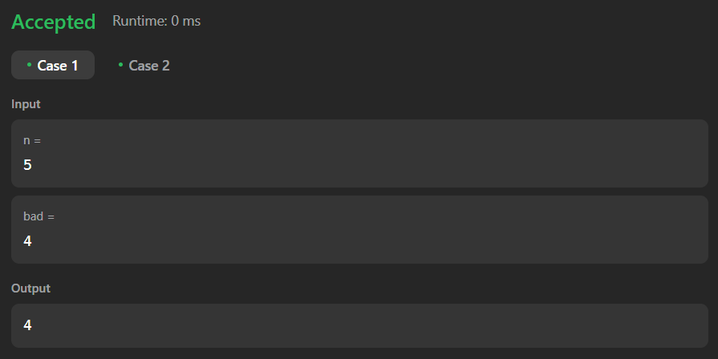

**Problem 3.** Sort Colors. - Given an array nums with n objects colored red, white, or blue, sort them in- place so that objects of the same color are adjacent, with the colors in the order red, white, and blue.

# Code:

class Solution {

public:

void sortColors(vector<int>& nums) {

int low = 0, mid = 0, high = nums.size()-1; while(mid <= high){

if(nums[mid] == 0){

swap(nums[low],

nums[mid]); low++;

mid++;

}

else if(nums[mid] == 1){ mid++;

}

else{

swap(nums[mid], nums[high]);

high--;

}

}

}

};

# Output:

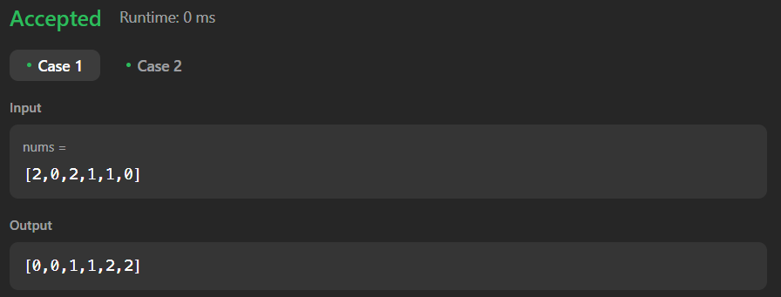

**Problem 4.** Top K frequent elements- Given an integer array nums and an integer k, return the k most frequent elements. You may return the answer in any order.

# Code:

class Solution { public:

vector<int> topKFrequent(vector<int>& nums, int k) {

int n = nums.size();

unordered_map<int, int> map; vector<int> ans;

for (int &x : nums) map[x]++; vector<vector<int>> arr(n + 1);

for (auto [a, b] : map) arr[b].push_back(a);

for (int i = n; i > 0; i--) {

for (int &x : arr[i]) {

if (ans.size() == k) return ans; ans.push_back(x);

}

}

return ans;

}

};

# Output:

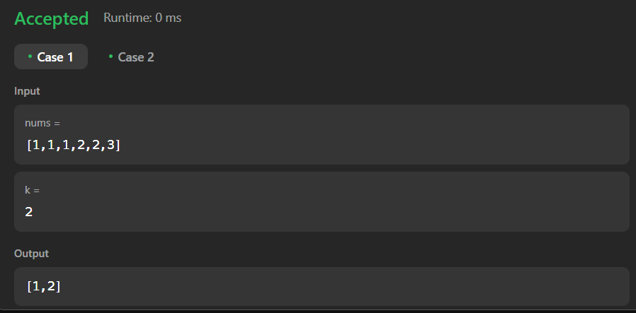

**Problem 5.** Kth Largest element in an array- Given an integer array nums and an integer k, return the kth largest element in the array.

# Code:

#include <queue> #include <vector>

using namespace std;

class Solution { public:

int findKthLargest(vector<int>& nums, int k) { priority_queue<int, vector<int>, greater<int>> minHeap;

for (int num : nums) { minHeap.push(num);

if (minHeap.size() > k) {

minHeap.pop(); // Remove smallest element

}

}

return minHeap.top();

}

};

# Output:

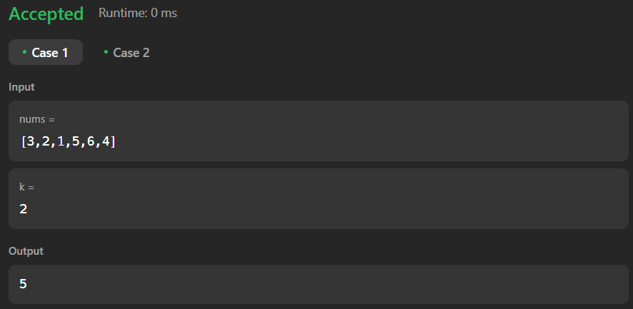

**Problem 6.** Find Peak Element-A peak element is an element that is strictly greater than its neighbors. Given a 0-indexed integer array nums, find a peak element, and return its index. If the array contains multiple peaks, return the index to any of the peaks..

# Code:

class Solution { public:

int findPeakElement(vector<int>& nums) {

int n=nums.size();

if(n==1)return 0;

int low=1, high=n-2; if(nums[0]>nums[1])return 0; if(nums[n-1]>nums[n-2])return n-1; while(low<=high){

int mid=low+(high-low)/2;

if(nums[mid]>nums[mid-1] && nums[mid]>nums[mid+1]) return mid;

else if(nums[mid]>nums[mid+1]){ high=mid-1;

}

else

low=mid+1;

}

return -1;

}

};

# Output:

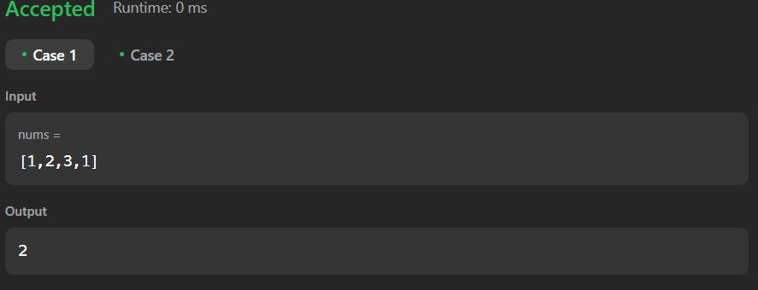

**Problem 7.** Merge Intervals- Given an array of intervals where intervals[i] = [starti, endi], merge all overlapping intervals, and return an array of the non-overlapping intervals that cover all the intervals in the input.

# Code:

class Solution { public:

vector<vector<int>> merge(vector<vector<int>>& intervals) { sort(intervals.begin(), intervals.end()); // Sort intervals by start time int k = 0; // Index for merged intervals

for (int i = 1; i < intervals.size(); i++) {

if (intervals[k][1] >= intervals[i][0]) { // Overlap detected intervals[k][1] = max(intervals[k][1], intervals[i][1]); // Merge

} else {

k++; // Move to the next position intervals[k] = intervals[i]; // Replace in-place

}

}

intervals.resize(k + 1); // Resize to include only merged intervals return intervals;

}

};

# Output:

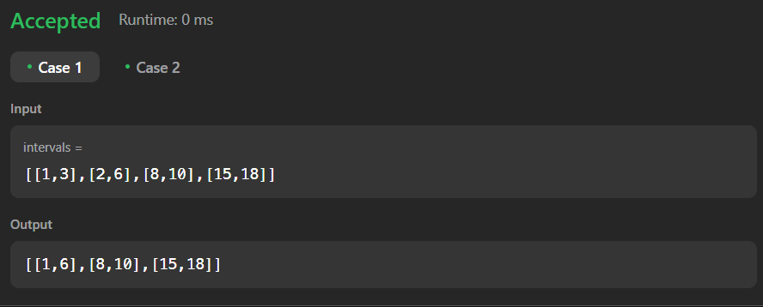

**Problem 8.** Search in Rotated Sorted Array - There is an integer array nums sorted in ascending order (with distinct values). Prior to being passed to your function, nums is possibly rotated at an unknown pivot index k (1 <= k < nums.length) such that the resulting array is [nums[k], nums[k+1], ..., nums[n-1], nums[0], nums[1], ..., nums[k-1]] (0-indexed). For example, [0,1,2,4,5,6,7] might be rotated at pivot index 3 and become [4,5,6,7,0,1,2].

# Code:

#include<vector> using namespace std; class Solution{

public:

int search(vector<int>&nums,int target){ int left=0,right=nums.size()-1; while(left<=right){

int mid=left+(right-left)/2; if(nums[mid]==target)return mid; if(nums[left]<=nums[mid]){

if(nums[left]<=target&&target<nums[mid]){ right=mid-1;

}else{

left=mid+1;

}

}else{

if(nums[mid]<target&&target<=nums[right]){ left=mid+1;

}else{

right=mid-1;

}

}

}

return-1;

};

# Output:

**Problem 9.** Search a 2D Matrix II - Write an efficient algorithm that searches for a value target in an m x n integer matrix matrix. This matrix has the following properties:

# Code:

class Solution { private:

bool search(vector<int>& arr, int target) { int low = 0, high = arr.size() - 1;

while (low <= high) {

int mid = low + (high - low) / 2; if (arr[mid] == target) return true;

else if (arr[mid] < target) low = mid + 1; else high = mid - 1;

}

return false;

}

public:

bool searchMatrix(vector<vector<int>>& matrix, int target) { int n = matrix.size(), m = matrix[0].size();

for (int i = 0; i < n; i++) {

if (search(matrix[i], target)) { return true;

}

}

return false;

}

};

# Output:

**Problem 10.** Kth smallest element in a sorted matrix - Given an n x n matrix where each of the rows and columns is sorted in ascending order, return the kth smallest element in the matrix.Note that it is the kth smallest element in the sorted order, not the kth distinct element.You must find a solution with a memory complexity better than O(n2).

# Code:

class Solution { public:

int kthSmallest(vector<vector<int>> &matrix, int k) {

int m = matrix.size(), n = matrix[0].size(); // For general, the matrix need not be a square priority_queue<int> maxHeap;

for (int r = 0; r < m; ++r) { for (int c = 0; c < n; ++c) {

maxHeap.push(matrix[r][c]);

if (maxHeap.size() > k) maxHeap.pop();

}

}

return maxHeap.top();

}

};

**Output:**

